

**BACHELOR’S DEGREE IN INFORMATION TECHNOLOGY**

------------------------------------------------------------------------------------

**FINAL YEAR PROJECT PROPOSAL**

------------------------------------------------------------------------------------

**STUDENT NAME : KATONGO BUPE**

**STUDENT NUMBER : 2010100**

**SUPERVISOR : MR. C. SILWIZYA**

------------------------------------------------------------------------------------

**PROJECT TITLE:**

**DESIGNING AND DEVELOPING A CENTRALIZED LOAN APPLICATION MANAGEMENT SYSTEM FOR MICRO-FINANCE COMPANIES (A CASE STUDY OF ZAMBIAN MICRO – FINANCE INSTITUTIONS)**

# Abstract

The concept of microfinance, involving the provision of small loans to underprivileged individuals and businesses, has emerged as a potent strategy for poverty alleviation. This research endeavors to address the challenge of poverty reduction by establishing a system that offers secure and unsecured loans to individuals, thereby granting them a pathway to economic empowerment. According to Morduch and Wydick (2005), Microfinances are particularly advantageous in developing countries such as Zambia, where microfinance institutions (MFIs) have become the primary funding source for microbusinesses, thus ensuring sustainable access to financial resources. However, a critical problem arises from the lack of a centralized platform for comparing interest rates and services across various MFIs, leading to inefficiencies in the loan application process.

The primary objective of this study is to develop a Centralized Loan Application Management System that harmonizes multiple microfinance institutions on a singular platform. Additionally, the project aims to create a Cross-Platform Centralized Loan Application Management System, automating the Loan Application Process. Moreover, the research endeavors to devise a Centralized Loan Application Management System that effectively mitigates the risk of loan defaults experienced by microfinance institutions.

This study tackles the question of how a Centralized Loan Application Management System can be created to accommodate multiple microfinance institutions on a single platform. It also delves into the development of a Cross-Platform Centralized System and explores strategies to reduce the occurrence of loan defaults within microfinance institutions. The scope of this research centers on clients and debtors in the context of a specific microfinance institution located in Ndola, Zambia. The proposed system will offer essential functionalities including login/registration, search, view, update, and application submission, presented through a user-friendly interface on both iOS and Android platforms. The application will be built using React Native and Node.js for the frontend and backend respectively, with SQLite serving as the database management system.

# CHAPTER ONE

## 1.0 Introduction

The concept of "microfinance" refers to the lending of small sums of money to under-privileged business people and ordinary people, this study intends to develop a system for reducing poverty by giving the individuals access secured and unsecured loans.

Microfinance has many advantages for developing countries like Zambia. This particular type of lending has been around for a while. In Africa and other developing nations, Microfinance institutions (MFIs) have become the primary source of funding for microbusinesses in many developing countries, providing sustainable access to financial resources (Zimba, M. 2016)

In the modern day and age, internet has become essential to everyone. This project focuses on the creation of a mobile application for an online centralized platform for microfinance Institutions.

## 1.1 Background of the Study

The concept of microfinance has gained prominence as a powerful approach for tackling poverty by providing small loans to disadvantaged individuals and businesses. This strategy aims to empower recipients economically and contribute to poverty alleviation. Microfinance institutions (MFIs) have become crucial in developing countries, including Zambia, where they serve as primary sources of funding for microbusinesses. However, the lack of a centralized platform for comparing services and interest rates across different MFIs has led to inefficiencies in the loan application process. These institutions play a pivotal role in ensuring consistent access to financial resources for microbusinesses, contributing to sustainable economic growth. Despite these benefits, challenges persist, such as the risk of loan defaults experienced by MFIs.

1.2 Aim

This study aims at designing and developing an effective Centralized Loan Application Management System that will centralize various MFIs, alleviating the challenge of comparing interest rates, digitizing the Loan Application process and automating payment reminders and Credit Scoring to reduce the risk of loan defaults experienced by microfinance institutions.

## 1.3 Problem Statement

The inflexibility of comparing interest rates and services between different microfinance Institutions becomes a challenge. According to Charity Munsaka and Felix Chileshe (2020). The challenges of accessing microfinance in rural areas in Zambia. The study found that one of the challenges is the inflexibility of comparing interest rates and services between different microfinance institutions. The study also found that borrowers in rural areas often have to travel long distances to access microfinance services. Additionally, Borrowers having access to the internet have to look up every microfinance company on the internet, this is time consuming and inefficient.

According to Michael Mumba and Bright Mwape (2020). The use of physical loan application forms in microfinance in Zambia. The study found that physical loan application forms are still widely used in Zambia, despite the availability of digital alternatives. The study also found that physical loan application forms can be time-consuming and inefficient, and can also lead to errors. A client/debtor has to submit hard copies of NRC and other required documents to a microfinance institution for a Loan application to be processed.

Handling loan defaults is a massive challenge most microfinance institutions face. According to Patrick Zulu and Charles Mulenga (2020). This study examines how local microfinance institutions in Zambia handle loan defaults. The study found that local microfinance institutions use a variety of methods to manage loan defaults, including: Credit scoring, where borrowers are given a score based on their credit. This score is used to determine the borrower's risk of defaulting on a loan. Personal visits, Lender may visit borrowers to discuss their loan repayment status, and Phone calls, Lenders may call borrowers to remind them of their loan repayment due dates.

## 1.3 Research Objectives

1. To develop a centralized loan application management system that shall allow borrowers to compare interest rates between different microfinance institutions.
2. To implement a cross platform mobile app that shall Digitize the Loan Application Process.
3. To develop a system that shall automate payment reminders and Credit Scoring in order reduce the risks of loan defaults experienced by micro-finance institutions.

## 1.4 Research Questions

While the research was being undertaken, a mirror of research questions has been identified using the objectives specified in the proposal.

1. How can a centralized loan application management system allow borrowers to compare interest rates between different microfinance institutions?
2. How can a cross platform mobile app Digitize the Loan Application Process?
3. How can automated payment reminder and Credit Scoring reduce the risks of loan defaults experienced by micro-finance institutions?

## 1.5 Significance of the Study

The significance of this study can be understood in the context of the following key points:

1. Streamlining Interest Rate Comparison:

The inability to compare interest rates and services between different microfinance institutions has been identified as a significant challenge. This study's objective of developing a centralized loan application management system that facilitates easy comparison of interest rates will greatly benefit both borrowers and MFIs. By providing a unified platform for borrowers to assess interest rates, they can make more informed decisions about loan options, contributing to increased financial literacy and more competitive lending practices.

1. Digitization of Loan Application Process:

The reliance on physical loan application forms in microfinance processes, despite the availability of digital alternatives, poses inefficiencies and barriers. The implementation of a cross-platform mobile app to digitize the loan application process is a significant step toward reducing administrative burdens, eliminating errors associated with manual data entry, and expediting application processing. This digitization not only enhances the user experience for borrowers but also modernizes the operational landscape of MFIs, aligning them with contemporary technological trends.

1. Automation of Payment Reminders and Credit Scoring:

The challenge of managing loan defaults is a pressing concern for microfinance institutions. By developing a system that automates payment reminders and credit scoring. Automated payment reminders can improve borrower accountability, reducing instances of delinquency, while credit scoring mechanisms enhance the accuracy of risk assessment, enabling MFIs to make more informed lending decisions. This contributes to the financial sustainability of both borrowers and MFIs.

## 1.6 Conceptual Framework

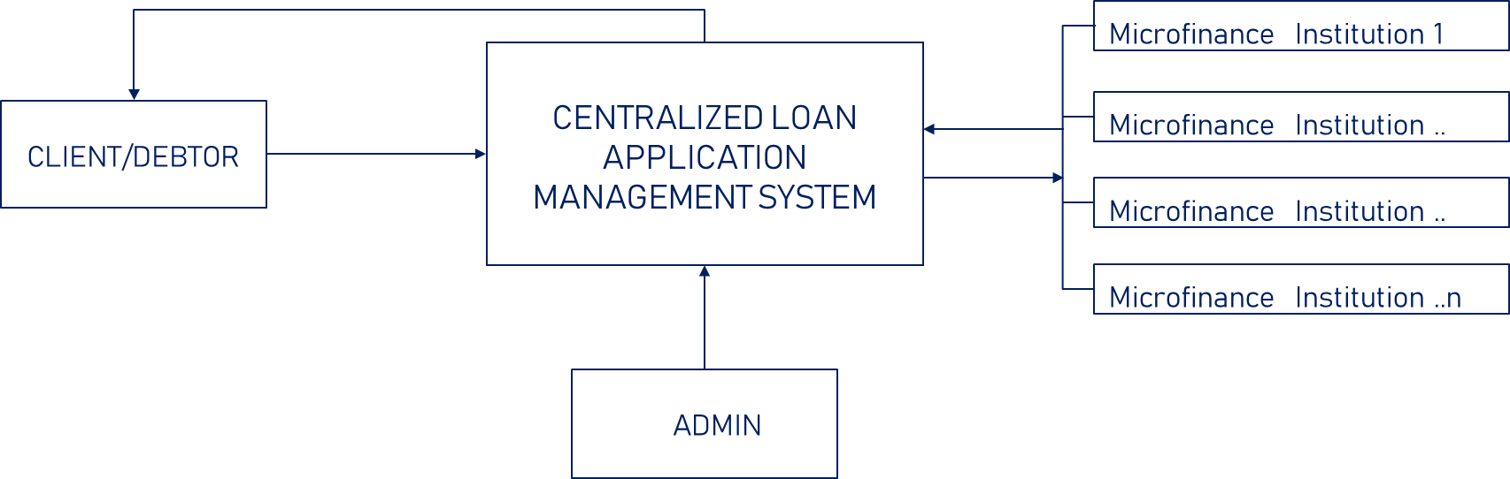

## 1.7 Purpose of the Study

The purpose of this study is to design and implement an innovative Centralized Loan Application Management System for microfinance institutions (MFIs) in Zambia. This system aims to address critical challenges within the microfinance sector, specifically focusing on the inefficiencies in interest rate comparison, the need for digitizing the loan application process, and the imperative to automate payment reminders and credit scoring. By achieving these objectives, the study seeks to contribute significantly to the enhancement of operational efficiency, user experience, and risk management within the microfinance landscape.

## 1.8 Scope of the Study

The scope of this study encompasses the design, development, and implementation of a Centralized Loan Application Management System tailored for microfinance institutions (MFIs) in Zambia. It includes the creation of a digital platform facilitating borrowers to conveniently compare interest rates and services offered by different MFIs. The study involves the development of a user-friendly cross-platform mobile application that streamlines and digitizes the loan application process, encompassing online forms and document uploads, thereby eliminating the need for physical paperwork. Additionally, the scope covers the design and implementation of automated systems for sending payment reminders to borrowers and assessing credit scores, contributing to enhanced borrower accountability and risk assessment for MFIs.

The system will be equipped with components to login/register, search, view, update and apply on the application while providing a custom user-friendly interface on both platforms (iOS & Android). The android/IOS application will be developed using React Native and Node.js as back-end language and Mongo DB as the database management system.

# CHAPTER TWO

# Literature Review

## 2.0 Introduction

The Literature was reviewed in three (3) phases corresponding to the objectives of this project.

1. The centralization of microfinance services has gained prominence as an effective strategy to address the challenges of accessibility and availability faced by the economically disadvantaged population. The utilization of software systems for comparing loan rates across multiple microfinance institutions has garnered significant attention in recent years due to its potential to transform the microfinance landscape.

The research paper by Sonia Singh and Hiranmay Saha (2011) sheds light on the imperative need for centralization in microfinance to enhance the accessibility and availability of financial services for impoverished individuals. By centralizing micro financial services under a unified umbrella, this approach has the potential to expedite poverty reduction efforts. The paper underscores the importance of addressing the missing link between lenders and borrowers, particularly within the Indian context, as a pivotal step toward achieving the goals of poverty reduction through microfinance. Centralization emerges as a key strategy in this endeavor, offering the promise of greater efficiency, accessibility, and ultimately, improved livelihoods for the economically disadvantaged.

The paper underscores the crucial role played by centralization in bridging this gap between lenders and borrowers, emphasizing that it is a prerequisite for reducing poverty effectively (Singh & Saha, 2011). Centralization not only facilitates the streamlining of microfinance operations but also promotes synergies among various stakeholders, making it easier for borrowers to access credit services.

The research paper by Richard Rosenberg, Adrian Gonzalez, and Sushma Narain (2009) raises important questions about the impact of high microcredit interest rates on impoverished individuals. While microfinance institutions argue that such rates are necessary for financial sustainability and service expansion, the paper prompts a critical examination of whether the poor are being exploited in the process. This discussion is essential for ensuring that the microfinance sector effectively fulfills its mission of poverty alleviation and empowerment without inadvertently creating new financial vulnerabilities for the very populations it aims to assist. The paper's findings and insights contribute to the ongoing discourse surrounding microcredit interest rates and their implications for the well-being of the economically disadvantaged.

The paper's theoretical framework centers on the evolving landscape of microfinance institutions (MFIs) in developing and transitional economies. Over the past two decades, MFIs have shifted their focus toward achieving financial sustainability by charging interest rates that are sufficiently high to cover their operational costs (Rosenberg et al., 2009). This strategic shift is underpinned by the belief that financial sustainability is essential for the long-term viability and expansion of microcredit services.

The paper critically examines the implications of this approach, particularly in terms of its impact on impoverished borrowers. It considers whether these high interest rates inadvertently transform microfinance providers into "new moneylenders" and explores the potential exploitation of low-income clients who may face significant financial burdens due to the cost of credit.

Lastly, another research paper by Christoph Kneiding and Richard Rosenberg (2008) underscores the importance of understanding and addressing the variations in microcredit interest rates on a global scale. While small loan sizes are a commonly cited reason for high microcredit interest rates, the paper goes further to investigate the multifaceted factors contributing to these disparities. The research not only raises questions about the impact of interest rate differentials on borrower welfare but also examines the role of competition and public policy in shaping the microcredit landscape.

The research paper explores several fundamental questions that shed light on the variations in microcredit interest rates:

* 1. Comparative Borrower Welfare:

The paper investigates how borrowers fare in both low-interest and high-interest microcredit environments. It seeks to understand the impact of interest rate disparities on the well-being of microcredit clients.

* 1. Competition and Efficiency:

The authors examine the relationship between competition among microfinance institutions (MFIs) and their operational efficiency. They assess whether increased competition necessarily results in lower microcredit interest rates.

* 1. Public Policy and Regulatory Environment:

The paper also delves into the role of public policy in influencing the domestic microfinance sector. It explores the characteristics of an "appropriate" regulatory environment that can foster responsible microcredit practices and ensure the interests of borrowers are protected.

1. The use of technology to digitize the loan application process in microfinance is a rapidly growing field. The five articles reviewed here provide an overview of the current state of the art, as well as insights into the potential benefits and challenges of this approach.

The research paper by Juliana Siwale and Cécile Godfroid (2021) underscores the need for a nuanced approach to digitizing microfinance. While digitization offers significant benefits, it also poses challenges, particularly in preserving the essential "human face" of microfinance institutions. The paper highlights the importance of maintaining personal relationships and trust between loan officers and clients, even as digital technologies are integrated into microfinance operations.

The research paper draws on questionnaires and semi-structured interviews with managers and loan officers from four microfinance institutions in Zambia to shed light on the complexities of digitizing the lending process. Several key findings and discussions emerge:

The Dilemma of Digitization: The paper addresses the dilemma of digitization in microfinance, particularly in mature markets. It raises concerns about the potential loss of the personal, trust-based relationships between loan officers and clients if digitization completely replaces human interaction.

Balancing Act: The study advocates for a blended approach that combines digital technologies with the flexibility and personal touch of loan officers. It argues that such an approach can help microfinance institutions maintain their competitive edge while enhancing the quality of soft information crucial for financial inclusion.

Soft Information and Trust: The paper emphasizes the importance of soft information in microfinance, which often relies on personal knowledge and relationships to assess borrowers' creditworthiness. It suggests that a complete shift to digital processes may compromise the collection and utilization of this critical information.

The research argues that a balanced approach, leveraging the strengths of both digital technologies and the human touch, is essential for microfinance institutions to remain competitive and continue fostering financial inclusion, particularly in less mature markets. This perspective contributes to the ongoing discourse on the evolving landscape of microfinance and the delicate balance between innovation and tradition in the pursuit of greater financial access for underserved populations.

In another research paper by C. M. Sarungu (2020) sheds light on the technological challenges and opportunities within the digital lending industry in Indonesia. It underscores the importance of automation, technology maturity, and a seamless user experience. The proposed system architecture aligns with local regulations and incorporates key national entities, demonstrating the need for a tailored approach in this dynamic industry.

The paper operates within the theoretical framework of digital lending, emphasizing the need for advanced technology and automation in the industry. It recognizes the significance of predictive machine learning algorithms in credit scoring models and the importance of integrating various technological components to create a seamless user experience.

The research paper discusses several key findings and issues in the context of digital lending in Indonesia:

Automation and Technology Maturity: The paper acknowledges the role of automation in accelerating processing speed within the digital lending sector. However, it highlights that certain aspects of digital lending, such as background checks on customers, still rely on third-party applications, indicating the need for technological maturity in these areas.

Loan Origination System: The paper underscores the importance of the loan origination system as the core component of the digital lending ecosystem. It discusses the need for continuous improvement and enhancement of this system to meet the evolving technological landscape.

Seamless User Experience: The research paper emphasizes the adoption of high-end mobile app technology to provide a seamless user experience for customers. Creating comfort and ease of use on digital lending platforms is crucial for customer satisfaction and engagement.

Planning and Roadmap: To keep up with the rapid pace of technological adoption in the digital lending industry, the paper suggests the importance of planning and creating a roadmap for technology stack development. This roadmap should align with local regulations and incorporate national entities, such as the national single ID server and local credit bureau.

Localization: The proposed software system architecture is designed to be specific to Indonesia, taking into account the country's unique regulatory environment and the inclusion of essential national entities within the digital lending ecosystem.

This research contributes to the understanding of the digital lending landscape in Indonesia and the necessity of technological advancements to meet the evolving needs of customers and regulatory requirements. It emphasizes the importance of a well-planned and adaptable technology roadmap to ensure the sustained growth and success of digital lending businesses in the Indonesian market.

1. The use of automated credit scoring and payment reminders is a growing trend in microfinance. These technologies can help microfinance institutions (MFIs) to reduce loan defaults by more accurately assessing the creditworthiness of borrowers and by reminding borrowers of their loan repayment obligations.

The research paper by N. Darapaneni, A. Kumar, A. Dixet, M. Suriyanarayanan, S. Srivastava, and A. R. Paduri (2022) underscores the transformative impact of AI/ML technologies on the credit process of financial institutions. By enhancing the accuracy of loan default prediction and credit scoring, these technologies contribute to risk reduction and informed lending decisions.

The paper introduces the Seven Seas loan prediction solution, emphasizing its potential benefits for financial institutions. It highlights the broad market scope for such a solution, not only in India but also globally, signaling the significant opportunities for financial institutions to embrace disruptive technology in their transformation initiatives.

The research paper addresses several key findings and issues related to loan prediction and financial technology:

Profitability and Risk Reduction: The paper acknowledges the pivotal role of credit business in a financial institution's profitability and discusses how AI/ML technologies are instrumental in significantly reducing the risk associated with loan defaults.

Data Science Techniques: It explores various data science techniques, such as logistic regression, SVM, neural networks, and random forests, and their contributions to enhancing the accuracy of loan default prediction. These techniques enable financial institutions to make more informed decisions regarding loan disbursements.

Credit Scoring Model: The paper outlines the development of an alternative credit scoring model using machine learning. This model aids in predicting creditworthiness, allowing financial institutions to set the terms of loan disbursements effectively.

Loan Origination Process: The research paper provides insights into the loan origination process, shedding light on the steps involved in loan application and evaluation, with a focus on the application of machine learning techniques.

This research contributes to the understanding of the role of AI/ML in financial technology and the potential for advanced data science techniques to optimize credit processes and reduce the risk of loan defaults in the financial sector.

Microloans have become a crucial financial tool for individuals in fragile economies, offering opportunities for economic growth and empowerment. However, the timely repayment of microloans remains a significant challenge, impacting both lenders and borrowers. This literature review explores the research article titled "A personal touch in text messaging can improve microloan repayment" authored by Dean Karlan, Melanie Morten, and Jonathan Zinman. The study investigates the effectiveness of personalized text message reminders in improving loan repayment rates for microloans in the Philippines. It highlights the potential and limitations of communication technology in addressing payment delays and defaults and underscores the importance of personal connections between borrowers and financial institution staff in overcoming market failures.

The research article by Dean Karlan, Melanie Morten, and Jonathan Zinman (2015) sheds light on the impact of personalized text message reminders on microloan repayment rates in the Philippines. It underscores the effectiveness of including the account officer's name in these messages, highlighting the role of personalization in borrower behavior.

The research article presents several key findings and discussions related to personalized text message reminders and microloan repayment:

Personalized Messages: The study demonstrates that personalized text message reminders were effective in improving loan repayment rates, but only when they included the account officer's name. This personal touch played a crucial role in encouraging borrowers to fulfill their repayment obligations.

Account Officer Relationship: The effectiveness of personalized messages was observed primarily for clients who had previously interacted with the account officer servicing their loans. This finding underscores the importance of the existing personal connection between borrowers and bank employees in enhancing loan repayment behavior.

The study contributes to the understanding of how communication technology can be harnessed to address payment delays and defaults in microfinance. It emphasizes the potential of personal connections between borrowers and financial institution staff in overcoming market failures and improving the efficiency of microloan programs. This research serves as a valuable reference for microfinance practitioners and policymakers seeking to enhance the repayment behavior of microloan borrowers through technology and personalization.

The prediction of loan defaults is of paramount importance for financial institutions and banks, as a significant portion of their revenue is reliant on the interest and EMIs generated from loan repayments. Many loans issued by financial institutions carry high interest rates due to the absence of collateral and the uncertainty associated with borrowers. Hence, the development of a model capable of predicting loan defaults holds immense value for financial institutions and banks. Such a model assesses customer data based on specific parameters and provides an accurate prediction, aiding financial institutions in making informed decisions about approving or rejecting loan applications. This literature review explores the research paper titled "Swindle: Predicting the Probability of Loan Defaults using CatBoost Algorithm" authored by S. Barua, D. Gavandi, P. Sangle, L. Shinde, and J. Ramteke. The paper was presented at the 2021 5th International Conference on Computing Methodologies and Communication (ICCMC) in Erode, India. It introduces "Swindle," a predictive model that utilizes the CatBoost algorithm for loan default prediction, incorporates a document verification module using Tesseract and Camelot, and integrates a personalized loan module to mitigate risks associated with loan issuance.

The paper operates within the theoretical framework of predictive modeling, machine learning, and financial risk assessment. It acknowledges the pivotal role of predictive models in evaluating the creditworthiness of borrowers and reducing the risk of loan defaults. The utilization of machine learning algorithms, such as CatBoost, underscores the importance of advanced analytics in enhancing loan default prediction.

The research paper presents several key findings and discussions related to Swindle and its capabilities:

Loan Default Prediction: Swindle employs the CatBoost algorithm to predict loan defaults accurately. This machine learning technique evaluates various customer parameters and historical data to provide a reliable prediction of whether a borrower is likely to default on their loan.

Document Verification Module: The paper introduces a document verification module using Tesseract and Camelot. This module ensures the authenticity and accuracy of documents submitted by borrowers, further reducing the risk of fraudulent loan applications.

Personalized Loan Module: Swindle incorporates a personalized loan module that tailors loan terms and conditions to individual borrowers. This approach enhances the institution's ability to cater to the specific needs and risk profiles of borrowers.

Risk Mitigation: The primary objective of Swindle is to mitigate the risk associated with loan issuance by providing financial institutions with a robust predictive model. By accurately assessing loan applicants and their likelihood of default, financial institutions can make informed lending decisions.

The research paper by S. Barua, D. Gavandi, P. Sangle, L. Shinde, and J. Ramteke (2021) introduces Swindle, a comprehensive model for predicting the probability of loan defaults. Utilizing the CatBoost algorithm, a document verification module, and a personalized loan module, Swindle addresses the critical challenges faced by financial institutions and banks in assessing borrower creditworthiness and managing risk.

The paper underscores the significance of advanced analytics and machine learning in enhancing loan default prediction, document verification, and personalized lending. Swindle represents a valuable tool for financial institutions seeking to make more informed decisions regarding loan approvals while reducing the risk of defaulters and unauthorized borrowers. This research contributes to the ongoing discourse on the application of technology and data analytics in the financial sector to enhance risk management and improve lending practices.

Credit scoring models play a crucial role in the assessment of borrowers' creditworthiness, enabling financial institutions to make informed lending decisions. This literature review explores the research paper titled "A Credit Scoring Model for Commercial Loans" authored by Yair E. Orgler. The paper was published in the Journal of Money, Credit and Banking in November 1970. It focuses on the development of a credit scoring model specifically tailored for commercial loans, aiming to enhance the accuracy and consistency of credit assessments in the financial industry.

|  |  |  |  |  |
| --- | --- | --- | --- | --- |
| Title | Author(s) and Year | Work Done | Gap Identified | Proposed Solution/Approach |
| Centralization of Microfinance | Sonia Singh, Hiranmay Saha (Jun 2011) | Discusses the growth and transformation of microfinance organizations and the missing link between lenders and borrowers in the Indian context. | Lack of a centralized platform for efficient interest rate comparisons across microfinance institutions. | Develop a Centralized Loan Application Management System to harmonize multiple microfinance institutions on one platform, enabling borrowers to compare interest rates. |
| Digitising Microfinance | Juliana Siwale, Cécile Godfroid (Nov 2021) | Examines the digitization of microfinance and its potential impact on financial inclusion and the "human face" of microfinance institutions. | The lack of traditional human touch in microfinance due to digitization. | Implement a digitized Loan application system for a blended approach, combining digital technologies with human interaction to enhance financial inclusion while retaining the human touch. |
| Loan Prediction Software for Financial Institutions | N. Darapaneni, A. Kumar, A. Dixet, M. Suriyanarayanan, S. Srivastava, A. R. Paduri (2022) | Presents the Seven Seas model as a solution for predicting loan defaults, aiding financial institutions in making informed lending decisions. | The need for accurate loan default prediction to aid financial institutions. | Development of a credit scoring Algorithm that focuses on first hand data presented from the credit client, this means a smaller dataset will mitigate expensive calculations to predict loan defaults. |
| A Personal Touch in Text Messaging | Dean Karlan, Melanie Morten, Jonathan Zinman (2020) | Investigates the impact of personalized text message reminders on microloan repayment in the Philippines. | Lack of personalized text message system for reminders for loan repayment. | Implement personalized in text messaging system for improved microloan repayment, enhancing borrower engagement and improving repayment rates. |

The paper operates within the theoretical framework of credit risk assessment and credit scoring models. It recognizes the importance of quantifying the creditworthiness of commercial loan applicants and the need for systematic and data-driven methods to evaluate borrowers' financial health and repayment capacity.

The research paper by Yair E. Orgler (1970) offer valuable insights into the development of a credit scoring model tailored for commercial loans. Such models have played a significant role in the financial industry by improving the efficiency of credit assessments and helping financial institutions manage credit risk effectively. This paper contributes to the ongoing evolution of credit scoring practices and their impact on lending decisions in the commercial sector.

Summary table of Literature Review

System Review

In the pursuit of addressing the key objectives of this project, it is crucial to examine existing systems and articles related to the central theme of microfinance institutions (MFIs) and their role in providing financial services to underserved populations. The landscape of such systems globally reflects varying degrees of technological advancement, particularly through mobile applications and web-based platforms. Through our research, we have identified several noteworthy systems and institutions, each with its unique strengths and limitations.

ZAMCASH is a prominent microfinance institution operating in Zambia, offering unsecured loans to individuals through both their website and Android application. While it plays a vital role in providing financial services to the underserved, there are notable limitations in its current setup. ZAMCASH does not support multiple microfinance institutions on its platform, lacks automated payment reminders for clients/debtors, and offers limited cross-platform compatibility. The absence of these features poses challenges in terms of borrower flexibility and efficient loan management.

Another notable MFI in Zambia, IZWE LOANS, faces similar limitations as ZAMCASH. It does not provide support for multiple microfinance institutions, lacks automated payment reminders, and does not offer cross-platform compatibility. These limitations may impact borrower experiences and the institution's competitiveness in the microfinance market.

LUPIYA, another microfinance institution operating in Zambia, distinguishes itself by offering automated payment reminders to its clients. This feature contributes to improved borrower experiences and higher loan repayment rates. LUPIYA also provides users with the flexibility to choose custom interest rates and conducts eligibility checks for clients/debtors seeking loans. However, it is worth noting that LUPIYA is not cross-platform; it primarily operates through its website.

FINCA: Operating in various countries, including Zambia, FINCA is another microfinance institution that faces similar limitations as the aforementioned institutions. It does not support multiple microfinance institutions on its platform, lacks automated payment reminders, and offers limited cross-platform compatibility. Addressing these limitations could significantly enhance its service offerings. FINCA provides secured loans, conducts eligibility checks in person with clients/debtors, and offers diverse payment methods, including hard cash, VISA, debit cards, MTN, and Airtel Money. Notably, FINCA's loan application process still relies on traditional methods involving pen-and-paper forms, and they manually remind clients/debtors to repay their loans.

In summary, while these microfinance institutions in Zambia play crucial roles in expanding financial inclusion, there are noteworthy gaps and limitations within their current systems. These gaps include the absence of support for multiple microfinance institutions on a single platform, the lack of automated payment reminders, and limited cross-platform compatibility. This project aims to address these gaps by developing a comprehensive Centralized Loan Application Management System that harmonizes multiple MFIs on one platform, digitizes the loan application and approval processes, and automates payment reminders and credit scoring. This holistic approach promises to enhance borrower experiences, streamline loan management, and reduce loan default risks, contributing significantly to the microfinance sector in Zambia and beyond.

|  |  |  |  |
| --- | --- | --- | --- |
| **EXISTING SYSTEMS** | **SUPPORTS MULTIPLE MICROFINANCE INSTITUIONS** | AUTOMATED PAYMENT REMINDERS | CROSS PLATFORM |
| ZAM-CASH | X | X | X |
| IZWE  LOANS | X | X | X |
| LUPIYA | X | $$√$$ | X |
| FINCA | X | X | X |
| PROPOSED SYSTEM | $$√$$ | $$√$$ | $$√$$ |

# CHAPTER THREE

# **RESEARCH METHODOLOGY**

## **Choice of methodology:**

Rapid Application Development (RAD) is a software development methodology that prioritizes speed and agility in delivering software solutions. RAD focuses on reducing development time and accelerating the delivery of functional software by emphasizing prototyping, iterative development, and close collaboration with customers.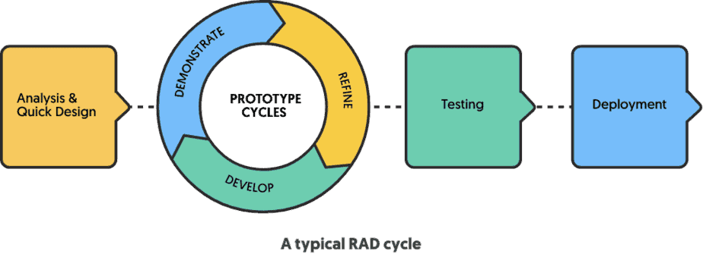

## 3.3 Layout

A complete description of the behavior of a system to be developed and may include a set of use cases that describe interactions the user will have with the software; in addition, it also contains non-functional requirements. Nonfunctional requirements impose constraints on the design or implementation (such as performance engineering requirements, quality standards or design constraints).

## 3.5 Functional Requirements

1. User Authentication and Authorization:

* Users should be able to register and log in to the system.
* Different user roles (e.g., admin, applicant) should have varying levels of access and permissions.

1. Loan Application Management:

* Applicants should be able to submit loan applications through the system.
* Loan officers should be able to review, approve, or reject loan applications.
* The system should support different types of loan products (e.g., personal loans, business loans).

1. Data Management:

* The system should securely store and manage applicant and member data.
* Loan officers should have the ability to update applicant information.

1. Loan Processing:

* The system should facilitate the processing of loan requests, including verifying applicant eligibility and creditworthiness.
* Loan officers should be able to calculate loan amounts, interest rates, and repayment terms based on predefined criteria.

1. Document Upload and Management:

* Applicants should be able to upload necessary documents for loan processing.
* Loan officers should have access to uploaded documents for review.

1. Communication and Notifications:

* The system should send notifications to applicants regarding the status of their loan application.

## 3.6 Non-Functional Requirement

1. Security:

* The system should ensure secure data transmission and storage, including encryption of sensitive information.
* User access should be protected through robust authentication mechanisms.

1. Usability and User Experience:

* The system should have an intuitive user interface to enhance user experience.
* It should be accessible from both Android and iOS devices.

1. Performance and Scalability:

* The system should be able to handle a high volume of concurrent users and loan applications.
* Response times should be reasonable even during peak usage.

1. Reliability and Availability:

* The system should have a high level of uptime and minimal downtime for maintenance.
* Backup and recovery mechanisms should be in place to prevent data loss.

1. Scalability:

* The system should be designed to accommodate future growth and additional features.

## **3.2 Development Tools**

|  |  |  |
| --- | --- | --- |
| **DEVELOPMENT** | **DESIGN** | **HARDWARE** |
| * React js, React Native, Node.js. * SQLite3, json-server * Microsoft Visual Studio Code (IDE) * Git and GitHub | * Microsoft Visio * FIGMA and Adobe XD | * Toshiba Satellite Pro Laptop R50-b (core i3, 4thgen, ram 8gb, 1.70 ghz) * Google Pixel 1 * iPhone X, 6s+ & 5s |

## **Schedule of Activities**

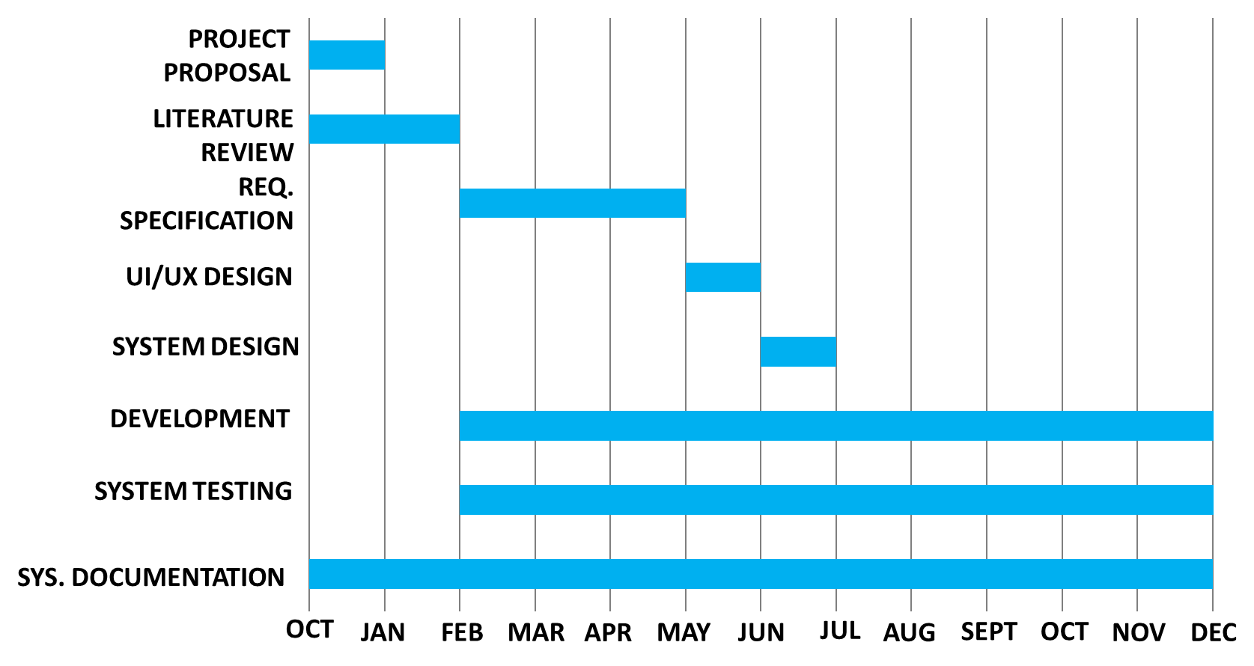

## **Budget**

|  |  |
| --- | --- |
| **Item Description** | **Budget (ZMW)** |
| **Equipment and Software** |  |
| - Computers and Laptops | **K6,500.00** |
| - Mobile Devices for Testing | **K7,500.00** |
| **Project Documentation and Training** |  |
| - Documentation and Manuals | **K2,500.00** |
| **Travel and Accommodation** |  |
| Miscellaneous Expenses | **K1,500.00** |
| **Total Project Budget** | **K 18,000.00** |

# CHAPTER FOUR

# RESEARCH RESULTS AND ANALYSIS